Project Planning Phase
Project Planning Template (Product Backlog, Sprint Planning, Stories, Story points)
Date | 15 February 2025
Team ID | SWTID-2026-6670
Project Name | Implement Client Script & UI Policy (Incident)
Maximum Marks | 5 Marks
Product Backlog, Sprint Schedule, and Estimation (4 Marks)
Product backlog and sprint schedule for the project "Implement Client Script & UI Policy (Incident)". Story points follow the scale 1 = very easy, 2 = normal, 3 = moderate, 5 = difficult.
Sprint | Functional Requirement (Epic) | User Story Number | User Story / Task | Story Points | Priority | Team Members
Sprint-1 | UI Policy Configuration | USN-1 | As an administrator, I can create the "High Impact Control" UI Policy on the Incident table (Active, condition: Impact is 1 - High, Reverse if false enabled) so that extra controls apply only to high-impact incidents. | 3 | High | [Your Name]
Sprint-1 |  | USN-2 | As an administrator, I can add a UI Policy Action that makes the Assignment group field mandatory when Impact is High. | 2 | High | [Your Name]
Sprint-1 |  | USN-3 | As an administrator, I can add a UI Policy Action that makes the Urgency field read-only when Impact is High, and reverts when Impact changes. | 2 | High | [Your Name]
Sprint-1 | Client Script Development | USN-4 | As a user, I want Urgency to be set to High automatically when I set Impact to High (onChange Client Script: Auto set urgency for high impact). | 3 | High | [Your Name]
Sprint-1 |  | USN-5 | As a service desk manager, I want the form to block saving a High-impact incident when Assigned To is empty, with an error message (onSubmit Client Script: Prevent save if Assigned To missing). | 3 | High | [Your Name]
Sprint-1 |  | USN-6 | As a service desk manager, I want the State field to be non-editable from the Incident list view, with an alert shown (onCellEdit Client Script: Prevent state change via list edit). | 2 | Medium | [Your Name]
Sprint-2 | Testing & Validation | USN-7 | As a tester, I can create a High-impact incident with Assigned To empty and verify the save is blocked and the error message appears. | 3 | High | [Your Name]
Sprint-2 |  | USN-8 | As a tester, I can fill Assigned To and verify the incident saves successfully with Urgency auto-set and read-only. | 2 | High | [Your Name]
Sprint-2 |  | USN-9 | As a tester, I can change Impact from High to Medium and verify Assigned To is no longer mandatory and Urgency is editable again (Reverse if false). | 2 | High | [Your Name]
Sprint-2 |  | USN-10 | As a tester, I can double-click State in the Incident list and verify the alert appears and the value remains unchanged. | 2 | Medium | [Your Name]
Sprint-2 |  | USN-11 | As a tester, I can update State from the Incident form and verify the change saves successfully. | 1 | Medium | [Your Name]
Sprint-2 | Project Documentation | USN-12 | As a project owner, I can document the configuration, scripts, screenshots, test results and conclusion for the project. | 3 | Medium | [Your Name]

Sprint Summary | Story Points
Sprint-1 (USN-1 to USN-6): 3+2+2+3+3+2 | 15
Sprint-2 (USN-7 to USN-12): 3+2+2+2+1+3 | 13
Total Story Points | 28
Project Tracker, Velocity & Burndown Chart: (4 Marks)
Sprint | Total Story Points | Duration | Sprint Start Date | Sprint End Date (Planned) | Story Points Completed (as on Planned End Date) | Sprint Release Date (Actual)
Sprint-1 | 15 | 6 Days | 05 Jan 2026 | 10 Jan 2026 | 15 | 10 Jan 2026
Sprint-2 | 13 | 6 Days | 12 Jan 2026 | 17 Jan 2026 | 13 | 17 Jan 2026
Total | 28 | 12 Days | 05 Jan 2026 | 17 Jan 2026 | 28 | 17 Jan 2026
Velocity:
Total story points completed = 15 + 13 = 28, over 2 sprints.
Velocity = Total Story Points Completed / Number of Sprints = 28 / 2 = 14 story points per sprint.
Average velocity (AV) per iteration unit, with a 6-day sprint duration:
AV = Velocity / Sprint Duration = 14 / 6 = 2.33 story points per day (approx.)
Burndown Chart:
A burn down chart is a graphical representation of work left to do versus time. It is often used in agile software development methodologies such as Scrum. However, burn down charts can be applied to any project containing measurable progress over time.
The chart below shows the 28 story points of this project burning down across Sprint-1 (Day 1-6) and Sprint-2 (Day 7-12), compared with the ideal burndown line.
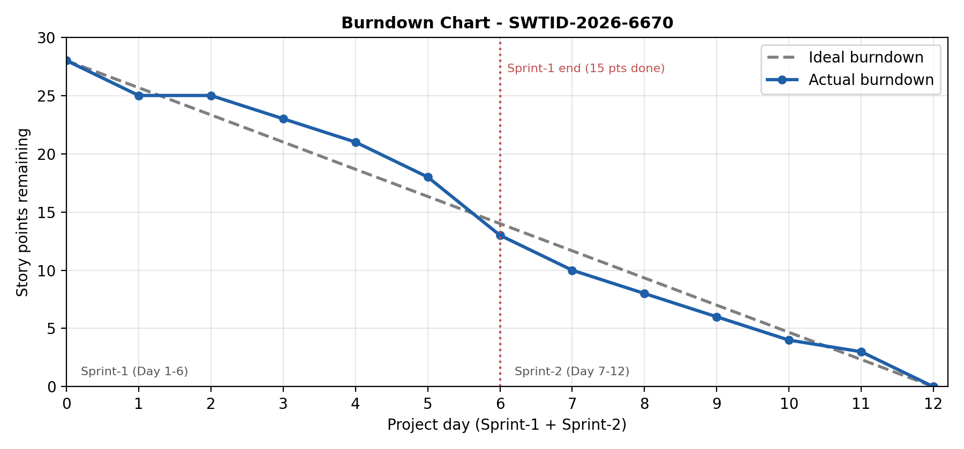
https://www.visual-paradigm.com/scrum/scrum-burndown-chart/
https://www.atlassian.com/agile/tutorials/burndown-charts
Reference:
https://www.atlassian.com/agile/project-management
https://www.atlassian.com/agile/tutorials/how-to-do-scrum-with-jira-software
https://www.atlassian.com/agile/tutorials/epics
https://www.atlassian.com/agile/tutorials/sprints
https://www.atlassian.com/agile/project-management/estimation
https://www.atlassian.com/agile/tutorials/burndown-charts

